**EXPERIMENT NO. 7**

**AIM**:  Simulation of Web Traffic in Packet Tracer.

**MATERIAL AND REQUIREMENTS:**

* + - Computer, Cisco Packet Tracer tool.

**Introduction to Web Traffic:**

Network traffic is the amount of data moving across a computer network at any given time. Network traffic, also called data traffic, is broken down into data packets and sent over a network before being reassembled by the receiving device or computer.

**Overview of Data Packets:**

When data travels over a network or over the internet, it must first be broken down into smaller batches so that larger files can be transmitted efficiently. The network breaks down, organizes, and bundles the data into data packets so that they can be sent reliably through the network and then opened and read by another user in the network. Each packet takes the best route possible to spread network traffic evenly.

**To send data packets have to following some steps such as: -**

1. **Step:** Open Cisco Packet Tracer.
2. **Step:**  Take two or more device or PC that is (PC 0, P1 & PC2).
3. **Step:**   Take a networking device that is switch and a server also.
4. **Step:**   Then connect all of the devices with the network device(switch).
5. **Step:**    Assign IP address to all the devices (PC 0, P1 & PC2 and Server0).

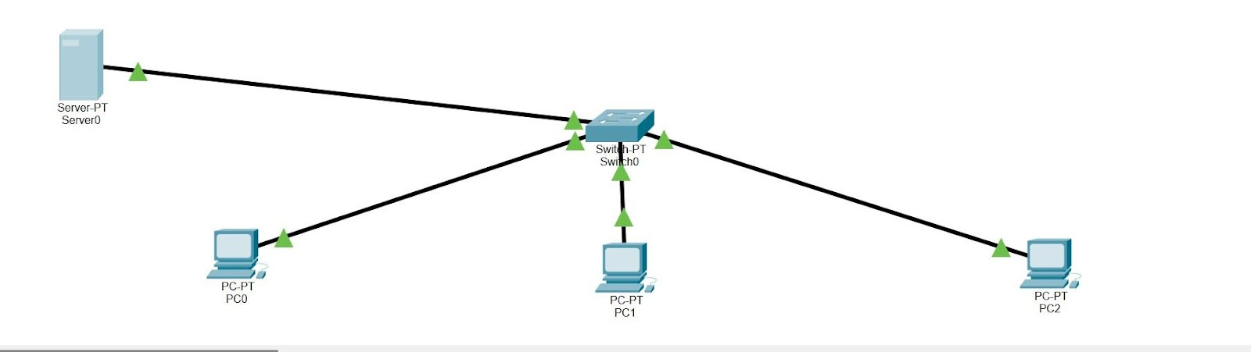  
  
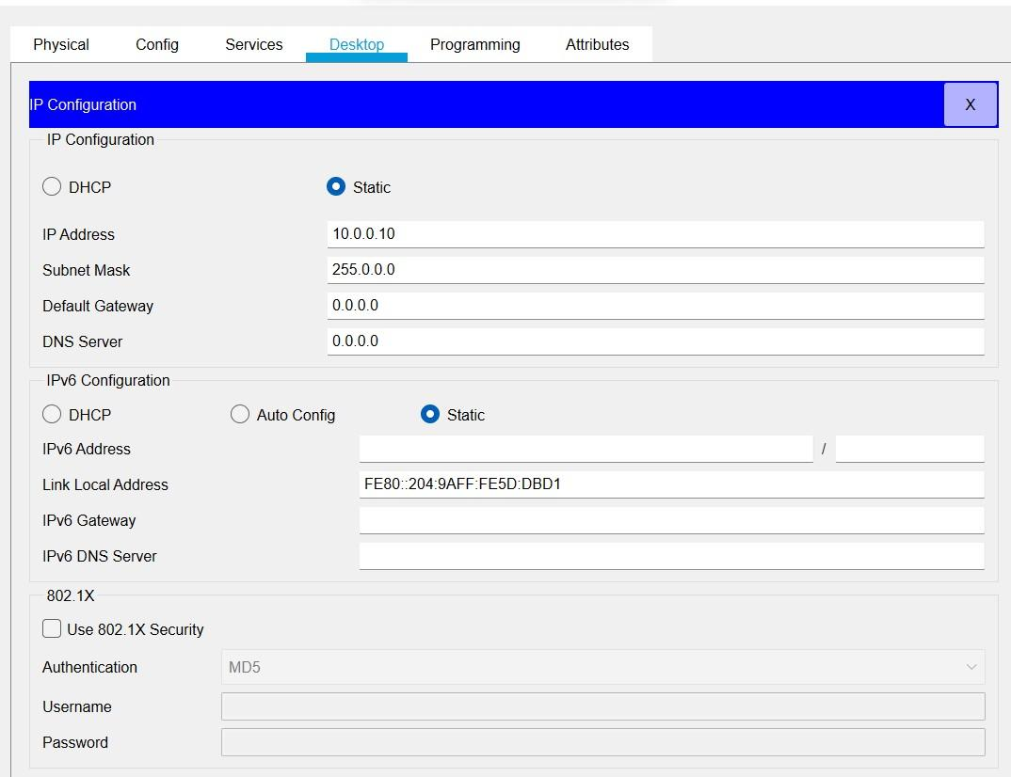

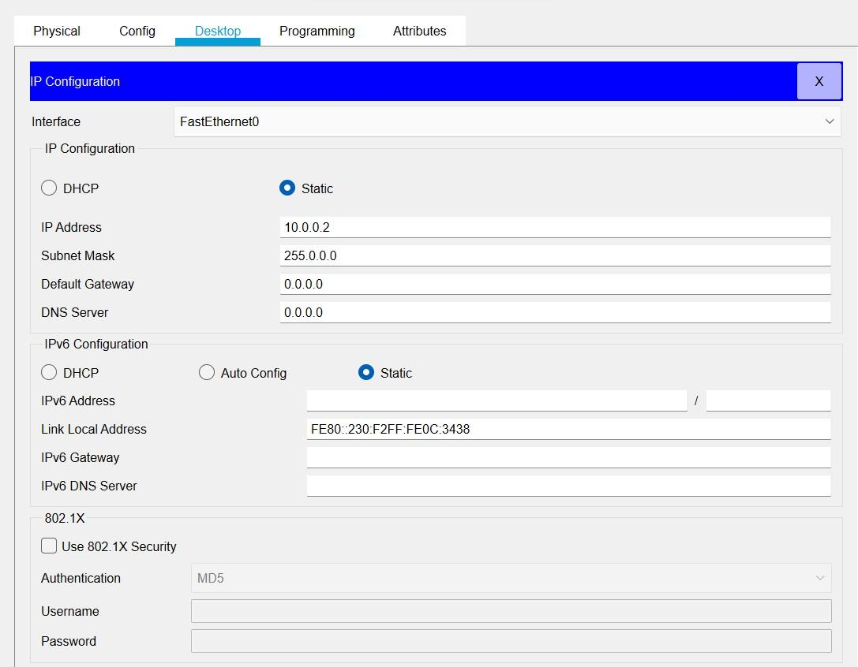  
  
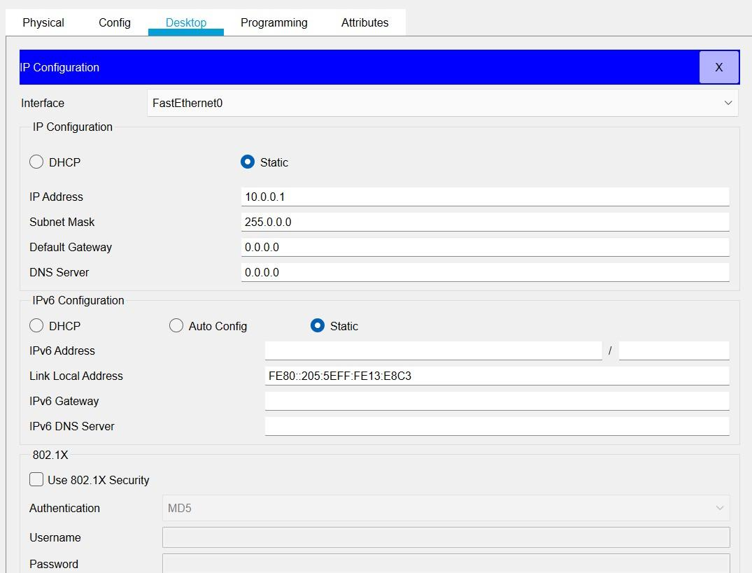  
  
  
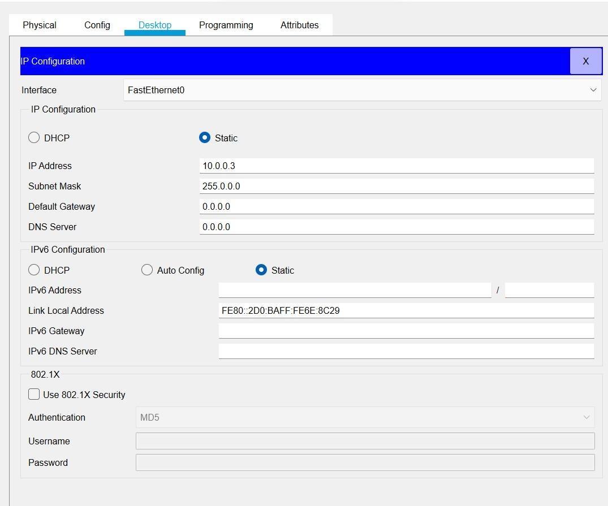

**5.Step:**    After assigning the IP addresses to all the devices to verify use ping command that is connected to each other or ready to communicate each other or not?

1. **Step:**   Hit ping command and check from PC1 to PC2, PC0 and Server0 and vice versa.

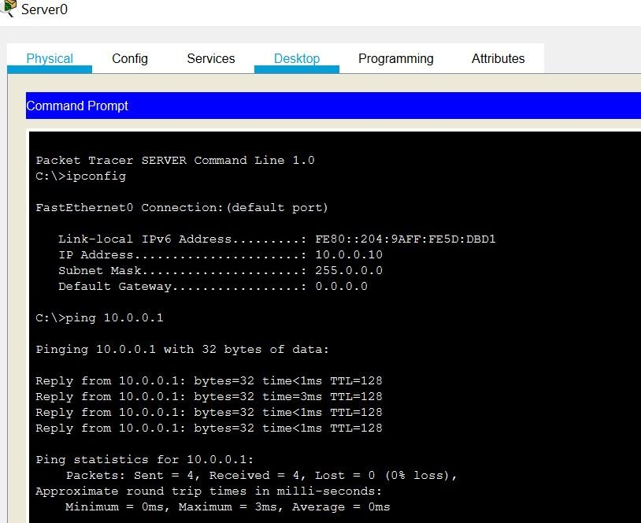  
  
  
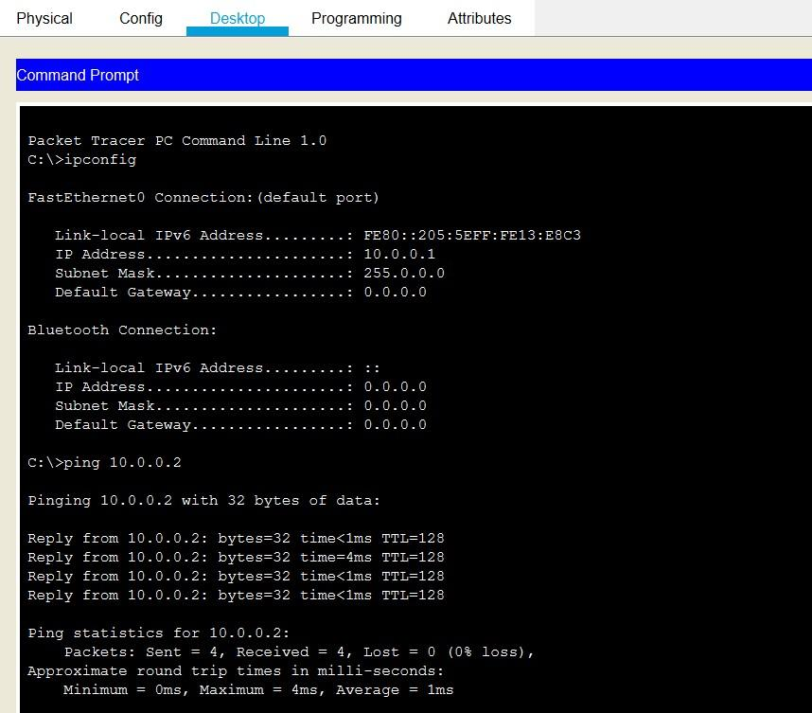  
  
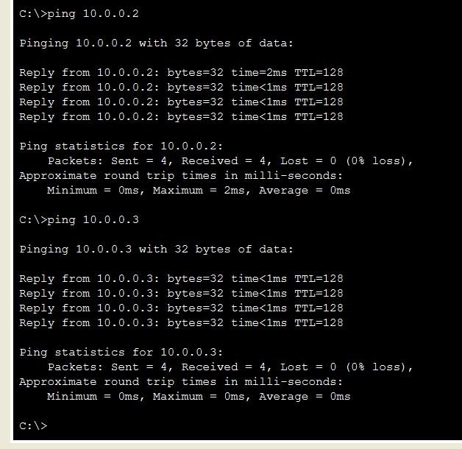  
  
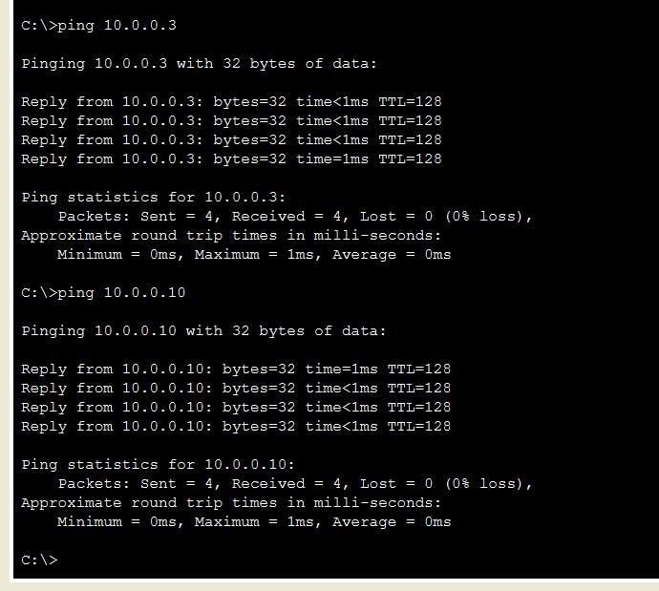

**7.Step:**   After all checks then on source PC and go to desktop and click on Traffic Generator.

1. **Step:**   After opening Traffic Generator assign Destination IP address   10.0.0.10Source IP Address    10.0.0.1Sequence Number   3

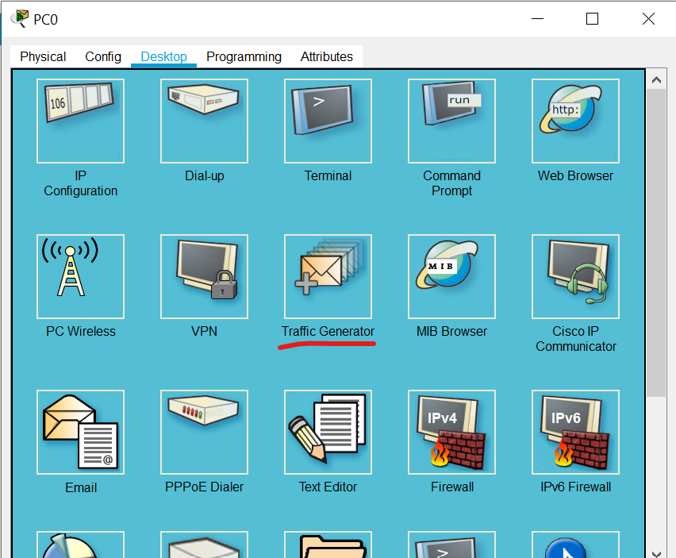  
  
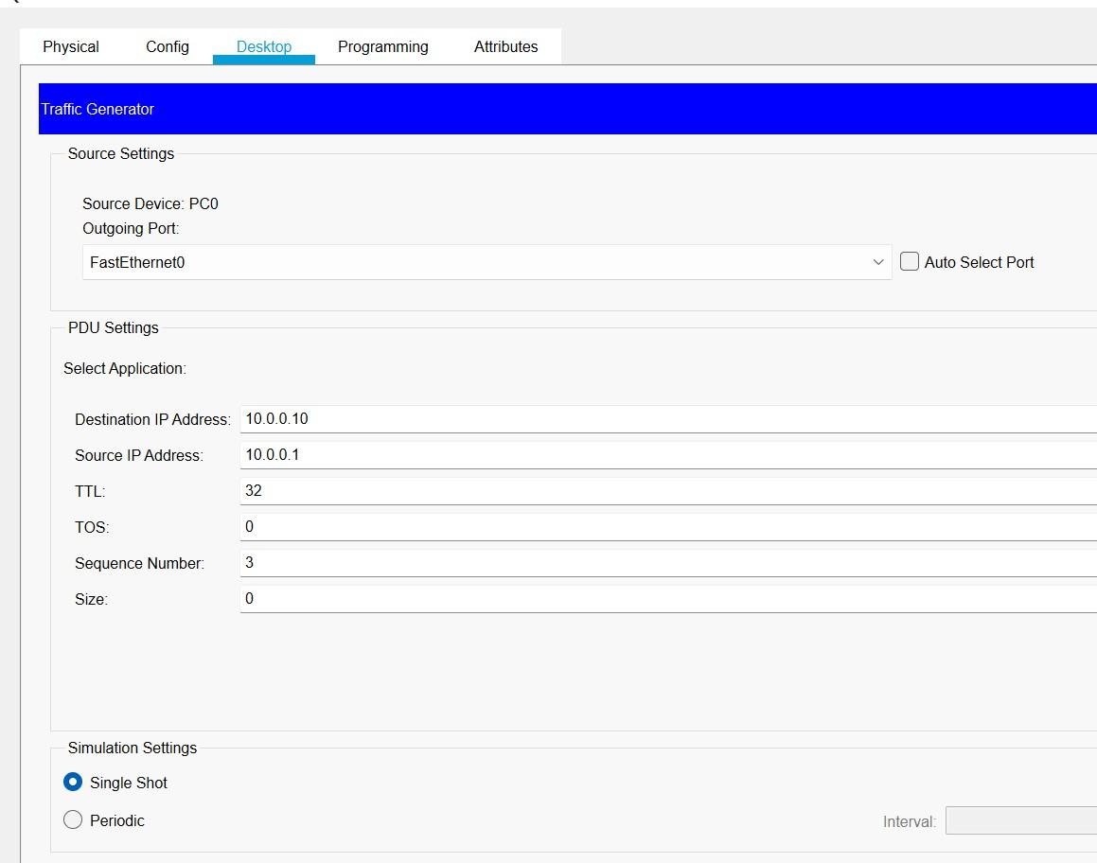  
  
**10.Step:** In the last step click on send button and check into simulation section.